QT APPLICATIONS DEBUGGING USING GDBSERVER WITH QT CREATOR

Introduction:

GDB, the GNU Project debugger, allows you to see what is going on `inside' another program while it executes or what another program was doing at the moment it crashed. GDB can do four main kinds of things (plus other things in support of these) to help you catch bugs in the act
- Start your program, specifying anything that might affect its behavior.
- Make your program stop on specified conditions.
- Examine what has happened, when your program has stopped.
- Change things in your program, so you can experiment with correcting the effects of one bug and go on to learn about another.
The program being debugged can be written in Ada, C, C++, Objective-C, Pascal (and many other languages). Those programs might be executing on the same machine as GDB (native) or on another machine (remote). GDB can run on most popular UNIX and Microsoft Windows variants.

GDB offers a 'remote' mode often used when debugging embedded systems. Remote operation is when GDB runs on one machine and the program being debugged runs on another. GDB can communicate to the remote 'stub' which understands GDB protocol via Serial or TCP/IP.

Require Tools and Packages for Debugging

1.Ethernet connection
2.GDB Tool in host
3.GDB Server in target for remote debug.
4.openssh with sftp server in target
5.Qt Creator

Types of Debugging
There are two types of debugging techniques is used
1.Terminal Debugging
2.GUI Debugging

Terminal Debugging
Debugging techniques is varying from host and remote debugging, gdb is used for host debugging and gdbserver is used for remote debugging.

Terminal Debugging on the host
To debug the program on the host compile the program with debug support using below command.

Examples:
1.Compile program with Debug support.
tamilarasi@ubuntu12:~/projects$ cc -g pgm.c
2.Run program with Debug support.
tamilarasi@ubuntu12:~/projects$ gdb ./a.out
tamilarasi@ubuntu12:~/program/cprogram$ gdb ./a.out
GNU gdb (Ubuntu/Linaro 7.4-2012.04-0ubuntu2.1) 7.4-2012.04
Copyright (C) 2012 Free Software Foundation, Inc.
License GPLv3+: GNU GPL version 3 or later <http://gnu.org/licenses/gpl.html>
This is free software: you are free to change and redistribute it.
There is NO WARRANTY, to the extent permitted by law. Type "show copying"
and "show warranty" for details.
This GDB was configured as "x86_64-linux-gnu".
For bug reporting instructions, please see:
<http://bugs.launchpad.net/gdb-linaro/>...
Reading symbols from /home/tamilarasi/program/cprogram/a.out...done.
(gdb) b main //break point at main
Breakpoint 1 at 0x4005d2: file arg.c, line 18.
(gdb) bt //back trace
No stack.
(gdb) r //run the program
Starting program: /home/tamilarasi/program/cprogram/a.out

Breakpoint 1, main (argc=1, argv=0x7fffffffe1a8) at arg.c:18
18 printf("enter num to send function\n");
(gdb) bt //information of the break point
#0 main (argc=1, argv=0x7fffffffe1a8) at arg.c:18
(gdb) info registers //information of the register
rax 0x7ffff7dd6568 140737351869800
rbx 0x0 0
rcx 0x400600 4195840
rdx 0x7fffffffe1b8 140737488347576
rsi 0x7fffffffe1a8 140737488347560
rdi 0x1 1
rbp 0x7fffffffe0c0 0x7fffffffe0c0
rsp 0x7fffffffe0a0 0x7fffffffe0a0
r8 0x400690 4195984
r9 0x7ffff7de9740 140737351948096
r10 0x7fffffffdf20 140737488346912
r11 0x7ffff7a3b680 140737348089472
r12 0x400460 4195424
r13 0x7fffffffe1a0 140737488347552
r14 0x0 0
r15 0x0 0
rip 0x4005d2 0x4005d2 <main+15>
eflags 0x206 [ PF IF ]
cs 0x33 51
ss 0x2b 43
ds 0x0 0
es 0x0 0
fs 0x0 0
gs 0x0 0
(gdb) watch strcpy //wach strcpy function
Hardware watchpoint 2: strcpy
(gdb) info watchpoints //num of watch points
Num Type Disp Enb Address What
2 hw watchpoint keep y strcpy
(gdb) list //llist the total program
13 }
14 main(int argc,char *argv[])
15 {
16 int i,j,k;
17 char (*p)(char *,char *),p1;
18 printf("enter num to send function\n");
19 //scanf(" %s",&argv[0]);
20 //p=&fun;
21 fun("embedded","yocto");
22 p=&fun;
(gdb) strace //number of strace
Note: breakpoint 1 also set at pc 0x4005d2.
warning: Couldn't determine the static tracepoint marker to probe
Static tracepoint 3 at 0x4005d2: file arg.c, line 18.
(gdb) select-frame
inferior info
(gdb) info frame //information of the frame
Stack level 0, frame at 0x7fffffffe080:
rip = 0x7ffff7aa3157 in __strlen_sse2 (../sysdeps/x86_64/multiarch/../strlen.S:54);
saved rip 0x7ffff7a8acec
called by frame at 0x7fffffffe0a0
source language asm.
Arglist at 0x7fffffffe070, args:
Locals at 0x7fffffffe070, Previous frame's sp is 0x7fffffffe080
Saved registers:
rip at 0x7fffffffe078
(gdb) q
quit the program.

Remote Debugging on the Terminal
To remote debug the program or application on the terminal compile the program with debug support for arm platform.
Before starting to remote debug connect ethernet network your host to target device with GDB server.

Remote debugging small C program on the terminal
1.Cross compile the program with debug support for arm platform
tamilarasi@ubuntu12:~/projects$ arm-poky-linux-gnueabi-gcc -g -o pgm pgm.c

2.Copy the program to target device
tamilarasi@ubuntu12:~/projects$ scp pgm root@192.168.x.x:/home/root/
192.168.x.x---> your target ip address
Now your program pgm is transfered to target device.

3.Start gdbserver on the target device using below command.
root@at91sam9x5ek:~# gdbserver :1234 pgm
Process TestApp created; pid = 1159
Listening on port 1234
Now your target is waiting for host response.

4.Run this below command on the host device.
tamilarasi@ubuntu12:~/targetdebug/Calc$ gdb -q pgm
Reading symbols from /home/tamilarasi/targetdebug/pgm...done.
(gdb) target remote 192.168.0.180:1234
Remote debugging using 192.168.0.180:1234
warning: while parsing target description (at line 1): Target description specified unknown architecture "arm"
warning: Could not load XML target description; ignoring
warning: Unable to find dynamic linker breakpoint function.
GDB will be unable to debug shared library initializers
and track explicitly loaded dynamic code.
(gdb) c
Continuing...

Remote debugging Qt Application on the terminal.

Cross compile the qt application with debug support for arm platform as follows.
1. Setup the Cross compile environment
tamilarasi@ubuntu12:~/targetdebug/Sample/Calc$ source /opt/poky/1.4.1/environment-setup-arm926ejste-poky-linux-gnueabi

2.Pass the qmake Path
tamilarasi@ubuntu12:~/targetdebug/Sample/Calc$ /opt/poky/1.4.1/sysroots/x86_64-pokysdk-linux/usr/bin/qmake

3.Compile the program
tamilarasi@ubuntu12:~/targetdebug/Sample/Calc$ make
Now you can binary file named as Calc

4. Copy the binary to target device
tamilarasi@ubuntu12:~/projects$ scp Calc root@192.168.x.x:/home/root/
192.168.x.x---> your target ip address
Now your program Cal is transferred to target device.

5. Start gdbserver on the target device using below command.
root@at91sam9x5ek:~# gdbserver :1234 Calc -qws
Process TestApp created; pid = 1159
Listening on port 1234
Now your target is waiting for host response.

6. Run below command on the host to debug the program
tamilarasi@ubuntu12:~/targetdebug/Calc$ gdb -q Calc
Reading symbols from /home/tamilarasi/targetdebug/Calc/Calc...done.
(gdb) target remote 192.168.0.180:1234
Remote debugging using 192.168.0.180:1234
warning: while parsing target description (at line 1): Target description specified unknown architecture "arm"
warning: Could not load XML target description; ignoring
warning: Unable to find dynamic linker breakpoint function.
GDB will be unable to debug shared library initializers
and track explicitly loaded dynamic code.
0x00000000 in ?? ()
(gdb) target remote 192.168.0.180:1234
Remote debugging using 192.168.0.180:1234
warning: while parsing target description (at line 1): Target description specified unknown architecture "arm"
warning: Could not load XML target description; ignoring
warning: Unable to find dynamic linker breakpoint function.
GDB will be unable to debug shared library initializers
and track explicitly loaded dynamic code.
0x00000000 in ?? ()
(gdb) b main
Breakpoint 1 at 0xa4f4: file main.cpp, line 5.
(gdb) watch
Argument required (expression to compute).
(gdb) watch main
Cannot watch constant value `main'.
(gdb) watch MainWindow
No symbol "MainWindow" in current context.
(gdb) list
1 #include <QtGui/QApplication>
2 #include "calc.h"
3
4 int main(int argc, char *argv[])
5 {
6 QApplication a(argc, argv);
7 Calc w;
8 w.show();
9
10 return a.exec();
(gdb) info registers
eax 0x0 0
ecx 0xbefffeb6 -1090519370
edx 0xbefffebb -1090519365
ebx 0x0 0
esp 0x0 0x0
ebp 0x0 0x0
esi 0x0 0
edi 0x0 0
eip 0x0 0
eflags 0x0 [ ]
cs 0x0 0
ss 0x0 0
ds 0x0 0
es 0xbefffdc0 -1090519616
fs 0x0 0
gs 0x4ccf0e30 1288638000
(gdb) c
Continuing.
Now your program starts running on the target device with debug support.

Application Debugging on Remote device using QT Creator and GDB Server

To Debug the qt application on the remote device configure the (build & run and Device) setup in your Qt creator for remote device.

Target Device Setup (poky device)
1. Install GDB 7.5.1 along with GDB Server in the target device
2. Install openssh6.1P1 with SFTP Server in the target device.
Compiled binary would be located in target device as follows
root@at91sam9x5ek:~# ls /usr/bin/
root@at91sam9x5ek:~# gdbserver
root@at91sam9x5ek:~# ls /usr/libexec/
root@at91sam9x5ek:~# sftp-server
Follow the Below Steps in the host qt creator

Open the Qt creator on the command line
tamilarasi@ubuntu12:~/qtsoftware/qtcreator-3.0.1/bin$ sudo ./qtcreator.sh

1. Creating New project
1. Go to File→ New Project-→Click Qt Widget Application.

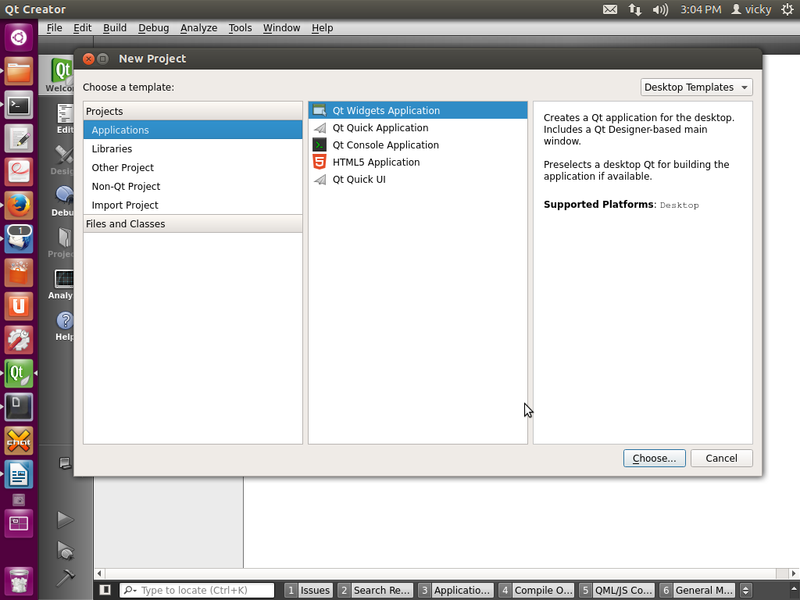

Click Choose button and Select your project location

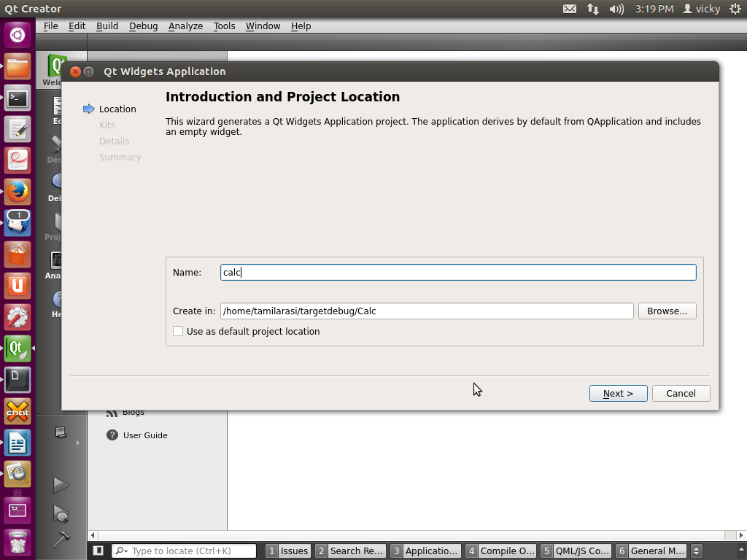
Click Next
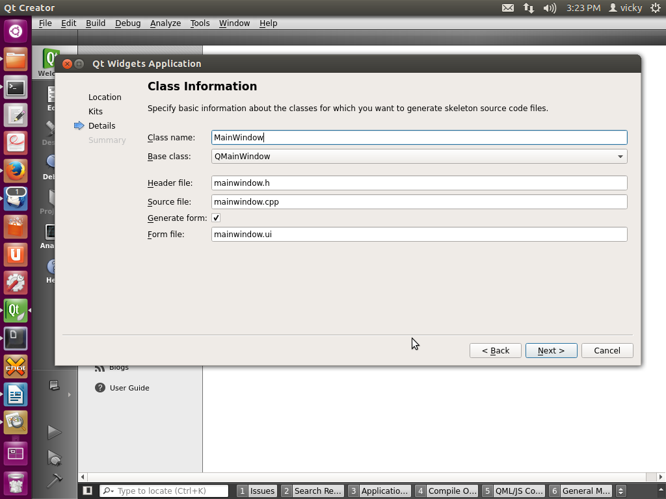

Click Next
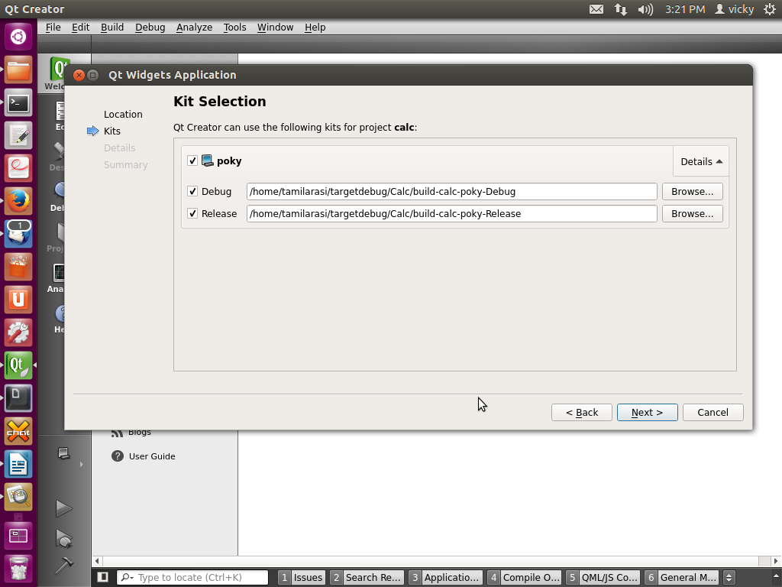

Click Next
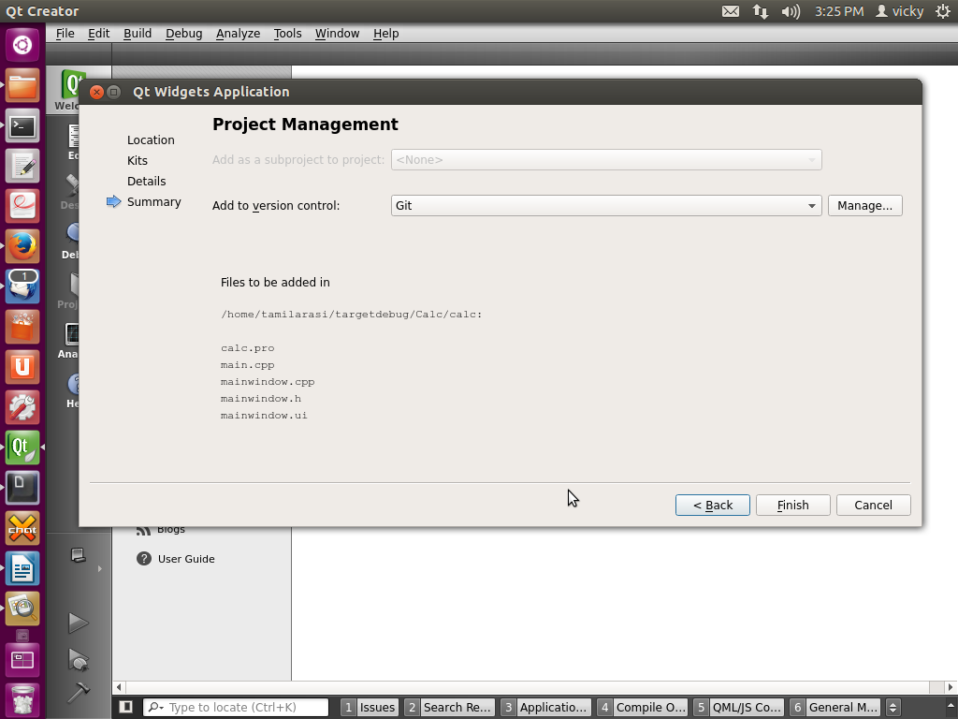

Now Click finish then your project window will open as follows

Click Next
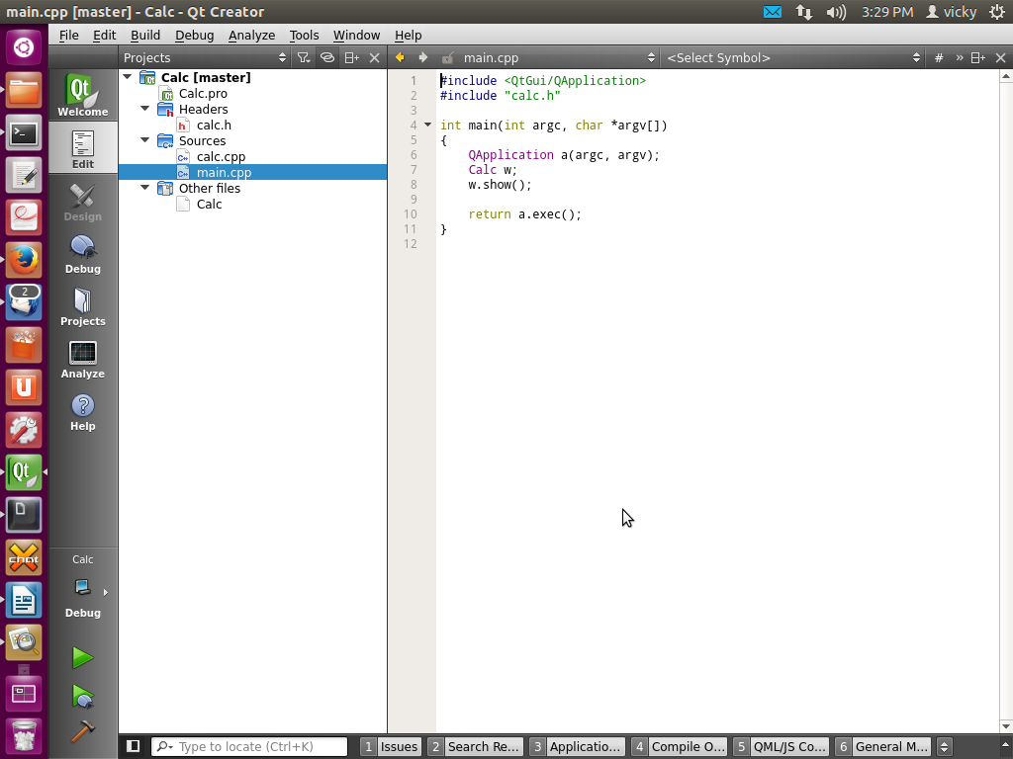

Modify your source file as per your requirement.
Note:
Before setting Build&run and Devices setup, Install poky SDK in your /opt directory.
To install poky Clancor SDK follow the given 71xx and 72xx document.doc in the linuxshare.

If your Poky SDK has installed, Now you are ready for remote set up in your Qt creator.

To Setup Qt creator for the Remote device
Go to Tools--->Select options
Click General and view the setup like this screenshot
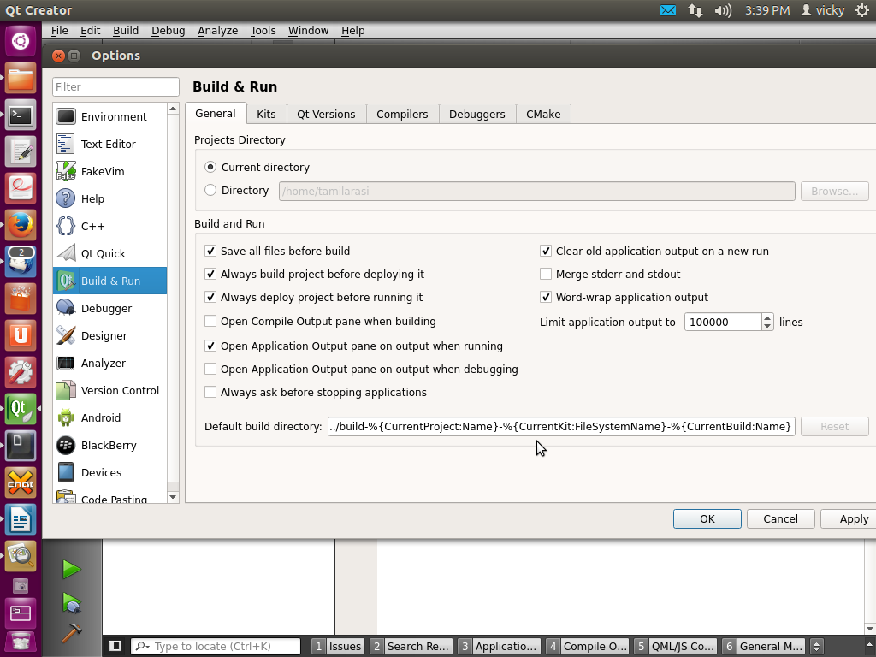
Click kit section and click Add button configure for poky remote device setup

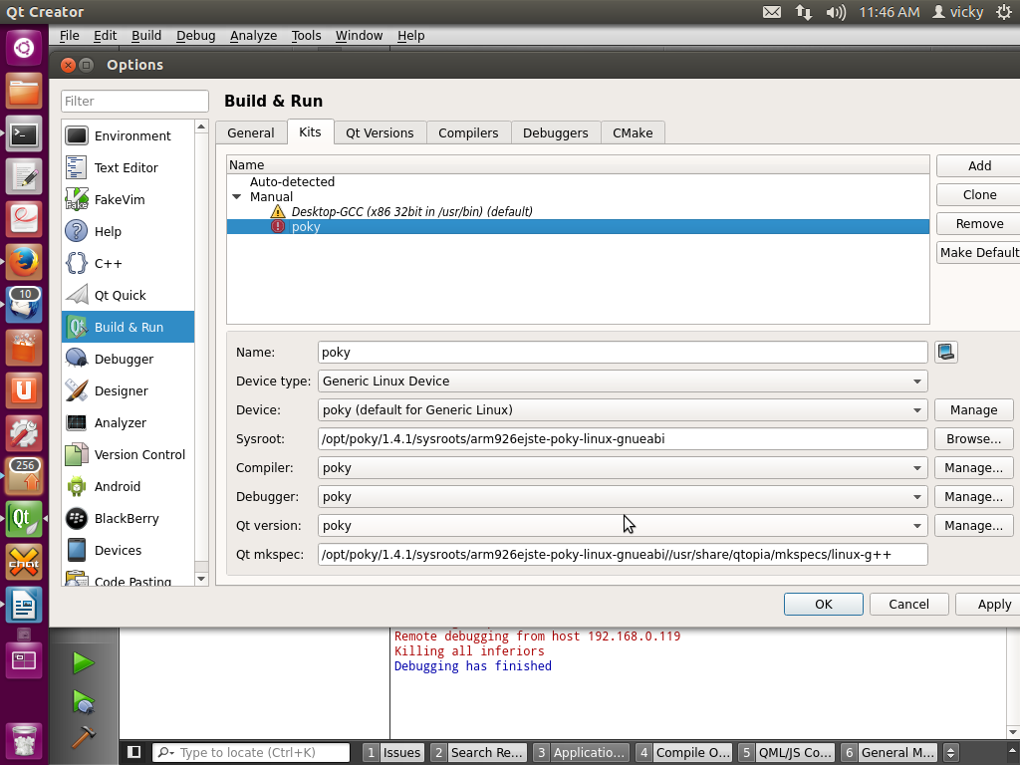

Qt version Setup
Set the qt version that is qmake path for remote device that is located /opt dir
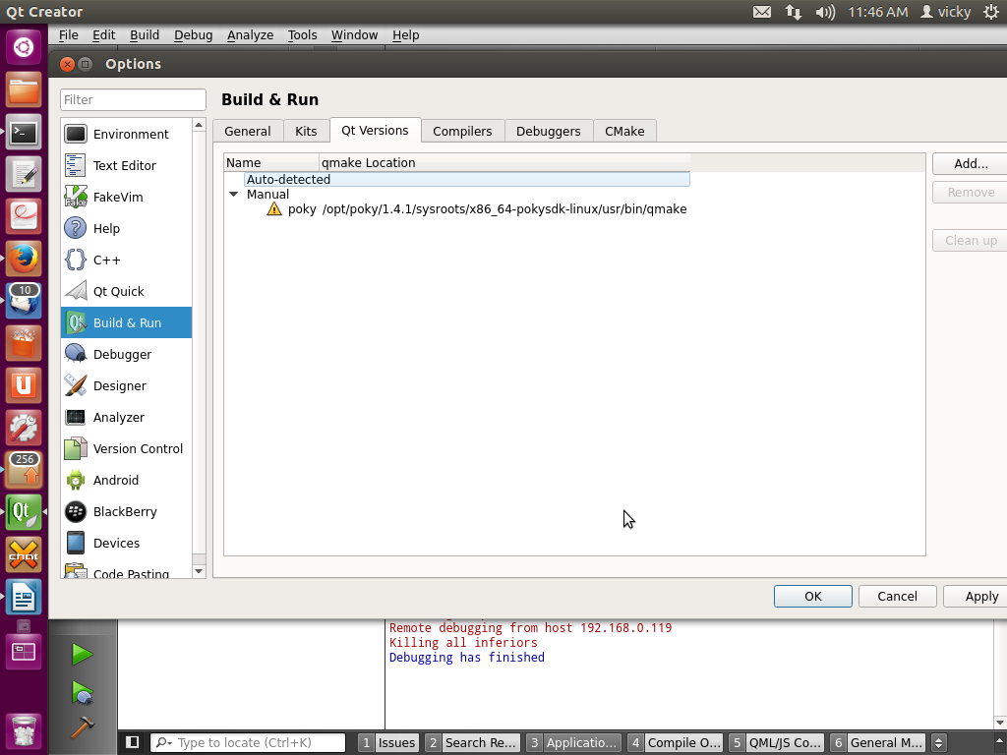

Setup the compiler path located at the /opt dir, click compiler path and select path.
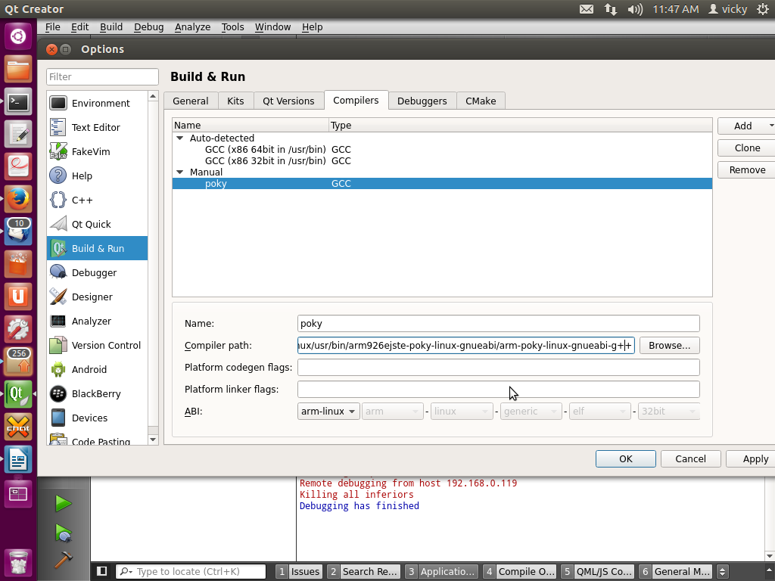
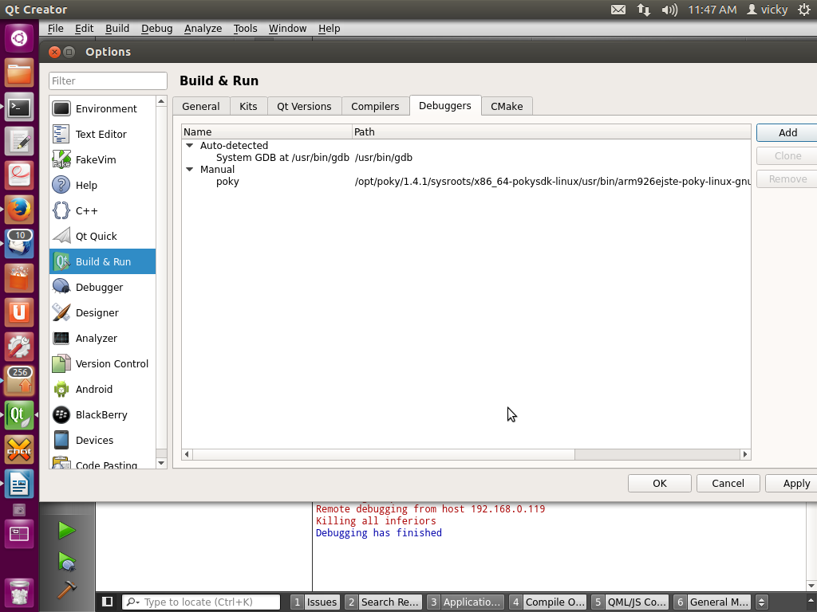
Setup debugger location in /opt dir

Now Build&run configuration setup finished for remote device.

Device Configuration
This device configuration is depends on the target device configuration.Enter your target IP address,username and password.

In this device configuration set the name as poky
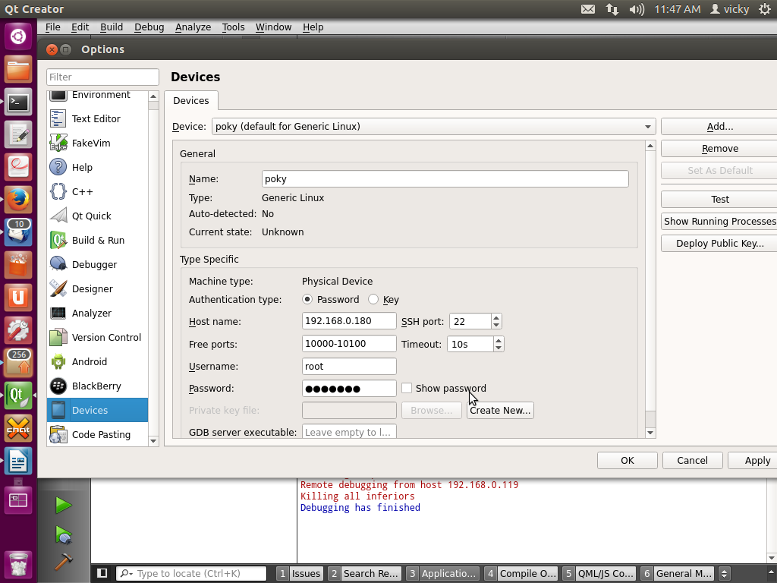

Now Click Apply button and click test button to check whether your target device is connected to host or not.

If your target device connected successfully

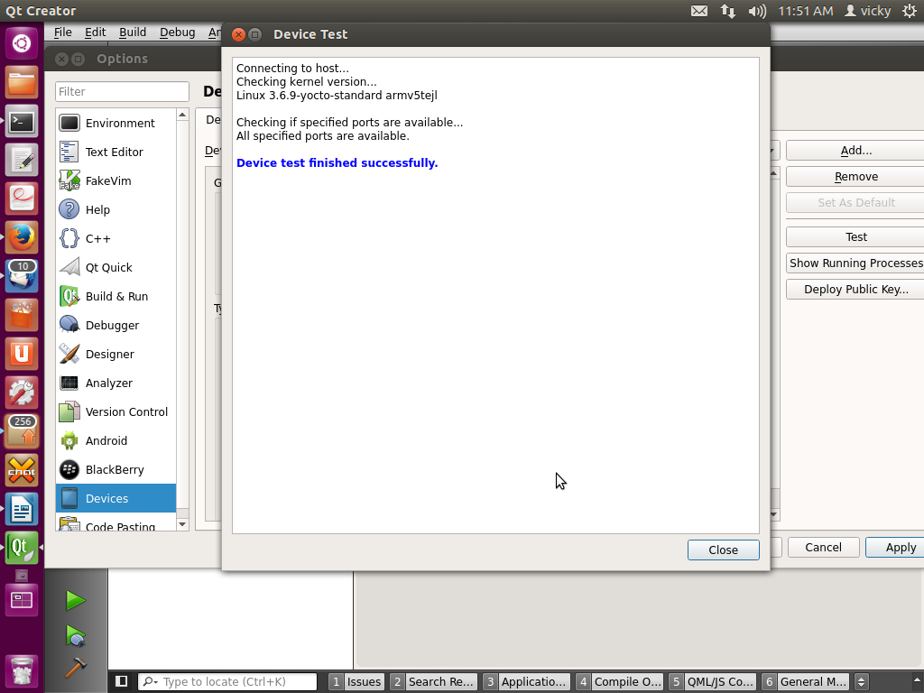

Now device setup completed.
Note
Add the below commands in your calc.pro file to communicate your Qt creatorvia gdbserver to your target /home/root/ directory.
TARGET = Calc
target.files = Calc
target.path = /home/root
INSTALLS += target

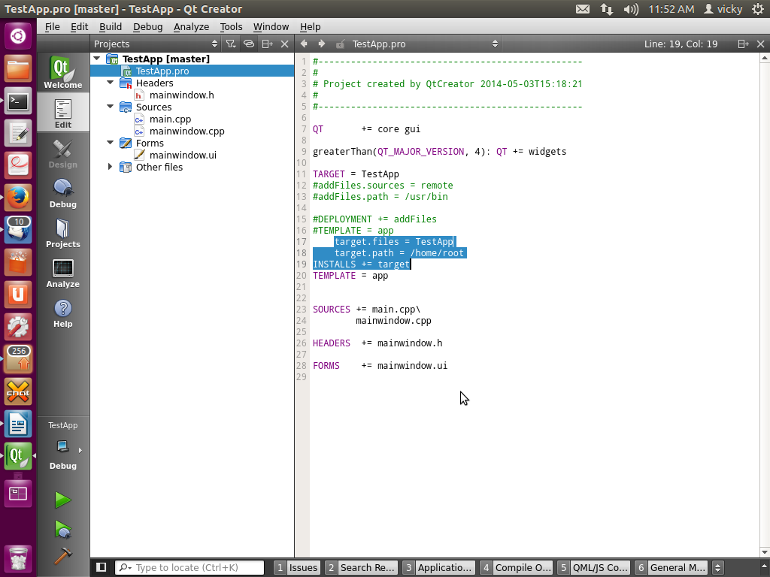
Add above highlighted command in the .pro file.

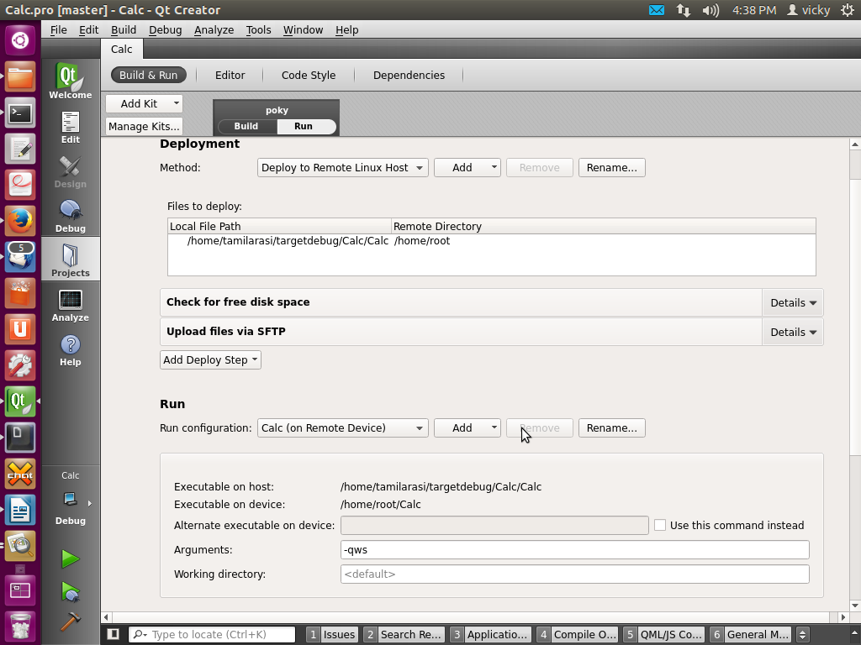
Save that .pro file, then you will get project file setup like this.
Now host and target communication started via gdb server.
Now build and run your project and you can view output like highlighted in the screen shot. About the target device.
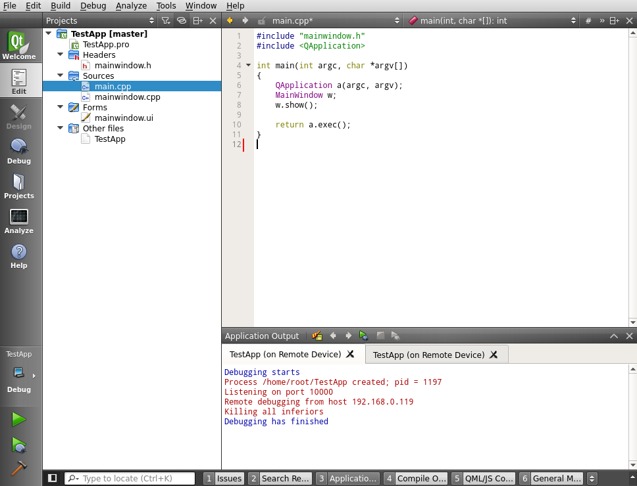
You can view the red colour highlighted message on qt terminal. If your project runs successfully on the target device.

GDB Example Commands for remote and host debug

Command | Description
help | List gdb command topics.
help topic-classes | List gdb command within class.
help command | Command description.
apropos search-word | Search for commands and command topics containing search-word.
info args  i args | List program command line arguments
info breakpoints | List breakpoints
info break | List breakpoint numbers.
info break breakpoint-number | List info about specific breakpoint.
info watchpoints | List breakpoints
info registers | List registers in use
info threads | List threads in use
info set | List set-able option
Break and Watch
break funtion-name  break line-number  break ClassName::functionName | Suspend program at specified function of line number.
break +offset  break -offset | Set a breakpoint specified number of lines forward or back from the position at which execution stopped.
break filename:function | Don't specify path, just the file name and function name.
break filename:line-number | Don't specify path, just the file name and line number.  break Directory/Path/filename.cpp:62
break *address | Suspend processing at an instruction address. Used when you do not have source.
break line-number if condition | Where condition is an expression. i.e. x > 5  Suspend when boolean expression is true.
break line thread thread-number | Break in thread at specified line number. Use info threads to display thread numbers.
tbreak | Temporary break. Break once only. Break is then removed. See "break" above for options.
watch condition | Suspend processing when condition is met. i.e. x > 5
clear  clear function  clear line-number | Delete breakpoints as identified by command option.
delete  d | Delete all breakpoints, watchpoints, or catchpoints.
delete breakpoint-number  delete range | Delete the breakpoints, watchpoints, or catchpoints of the breakpoint ranges specified as arguments.
disable breakpoint-number-or-range  enable breakpoint-number-or-range | Does not delete breakpoints. Just enables/disables them.  Example:  Show breakpoints: info break  Disable: disable 2-9
enable breakpoint-number once | Enables once
continue  c | Continue executing until next break point/watchpoint.
continue number | Continue but ignore current breakpoint number times. Usefull for breakpoints within a loop.
finish | Continue to end of function.
Line Execution
step  s  step number-of-steps-to-perform | Step to next line of code. Will step into a function.
next  n  next number | Execute next line of code. Will not enter functions.
until  until line-number | Continue processing until you reach a specified line number. Also: function name, address, filename:function or filename:line-number.
info signals  info handle  handle SIGNAL-NAME option | Perform the following option when signal recieved: nostop, stop, print, noprint, pass/noignore or nopass/ignore
where | Shows current line number and which function you are in.
Stack
backtrace  bt  bt inner-function-nesting-depth  bt -outer-function-nesting-depth | Show trace of where you are currently. Which functions you are in. Prints stack backtrace.
backtrace full | Print values of local variables.
frame  frame number  f number | Show current stack frame (function where you are stopped)  Select frame number. (can also user up/down to navigate frames)
up  down  up number  down number | Move up a single frame (element in the call stack)  Move down a single frame  Move up/down the specified number of frames in the stack.
info frame | List address, language, address of arguments/local variables and which registers were saved in frame.
info args  info locals  info catch | Info arguments of selected frame, local variables and exception handlers.
Source Code
list  l  list line-number  list function  list -  list start#,end#  list filename:function | List source code.
set listsize count  show listsize | Number of lines listed when list command given.
directory directory-name  dir directory-name  show directories | Add specified directory to front of source code path.
directory | Clear sourcepath when nothing specified.
Machine Language
info line  info line number | Displays the start and end position in object code for the current line in source.  Display position in object code for a specified line in source.
disassemble 0xstart 0xend | Displays machine code for positions in object code specified (can use start and end hex memory values given by the info line command.
stepi  si  nexti  ni | step/next assembly/processor instruction.
x 0xaddress  x/nfu 0xaddress | Examine the contents of memory.  Examine the contents of memory and specify formatting.  - n: number of display items to print  - f: specify the format for the output  - u: specify the size of the data unit (eg. byte, word, ...)  Example: x/4dw var
Examine Variables
print variable-name  p variable-name  p file-name::variable-name  p 'file-name'::variable-name | Print value stored in variable.
p *array-variable@length | Print first # values of array specified by length. Good for pointers to dynamicaly allocated memory.
p/x variable | Print as integer variable in hex.
p/d variable | Print variable as a signed integer.
p/u variable | Print variable as a un-signed integer.
p/o variable | Print variable as a octal.
p/t variable  x/b address  x/b &variable | Print as integer value in binary. (1 byte/8bits)
p/c variable | Print integer as character.
p/f variable | Print variable as floating point number.
p/a variable | Print as a hex address.
x/w address  x/4b &variable | Print binary representation of 4 bytes (1 32 bit word) of memory pointed to by address.
GDB Modes
set gdb-option value | Set a GDB option
set logging on  set logging off  show logging  set logging file log-file | Turn on/off logging. Default name of file is gdb.txt
set print array on  set print array off  show print array | Default is off. Convient readable format for arrays turned on/off.
set print array-indexes on  set print array-indexes off  show print array-indexes | Default off. Print index of array elements.
set print pretty on  set print pretty off  show print pretty | Format printing of C structures.
set print union on  set print union off  show print union | Default is on. Print C unions.
set print demangle on  set print demangle off  show print demangle | Default on. Controls printing of C++ names.
Start and Stop
run  r  run command-line-arguments  run < infile > outfile | Start program execution from the beginning of the program. The command break main will get you started. Also allows basic I/O redirection.
continue  c | Continue execution to next break point.
kill | Stop program execution.
quit  q | Exit GDB debugger.

